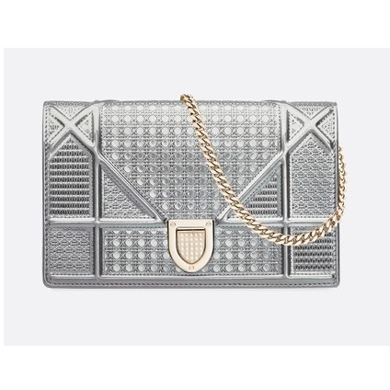

Diorama calfskin clutch

PRODUCT DETAILS

**Diorama Wallet on Chain clutch in sky blue metallic calfskin with 'Micro-cannage' motif.**